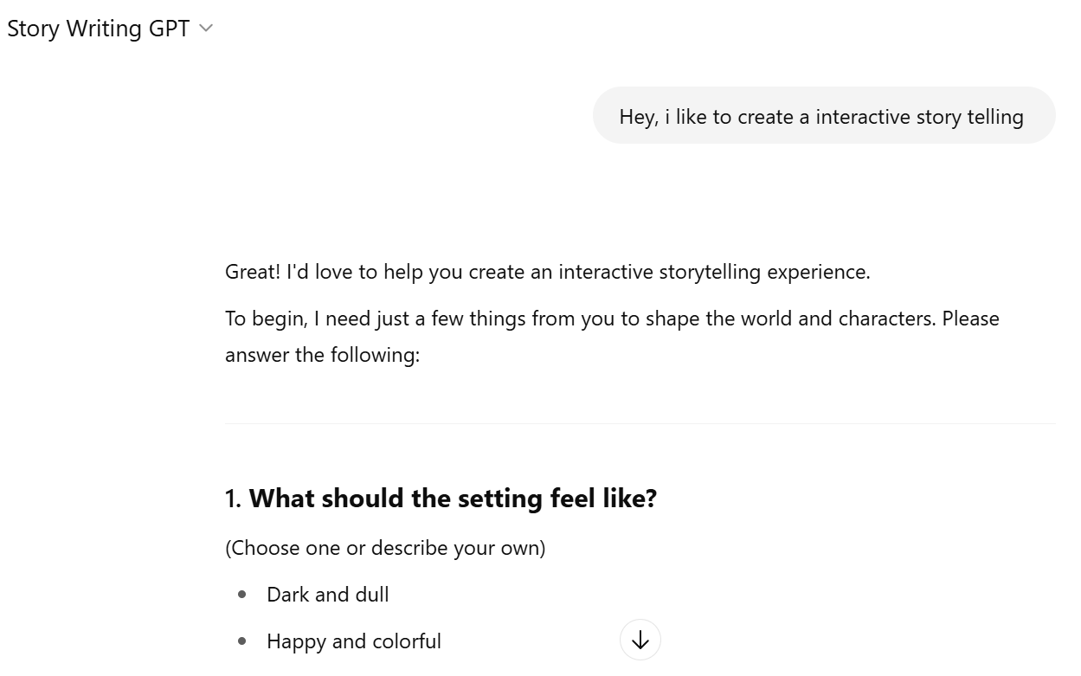

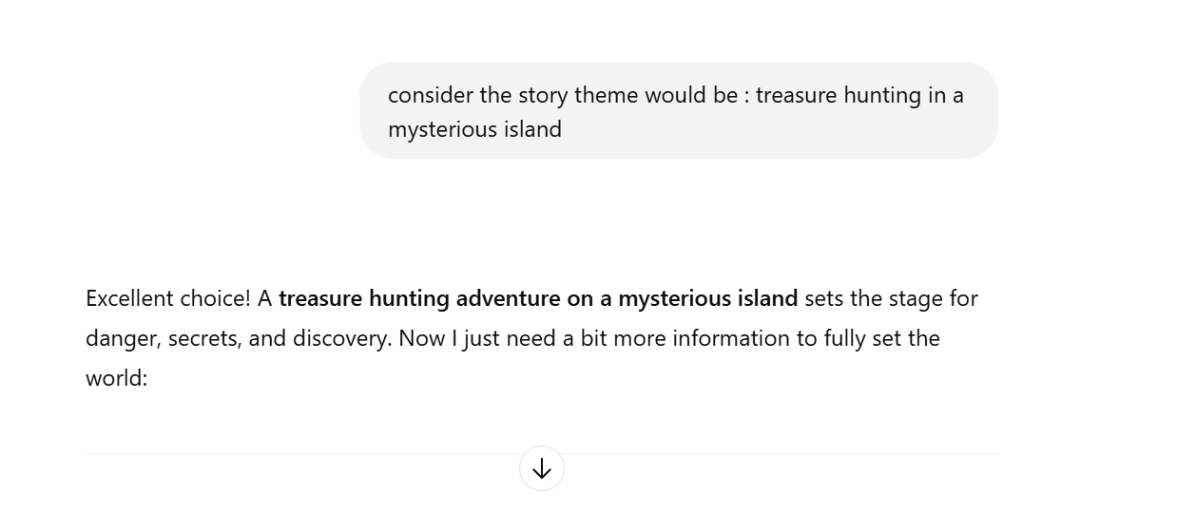

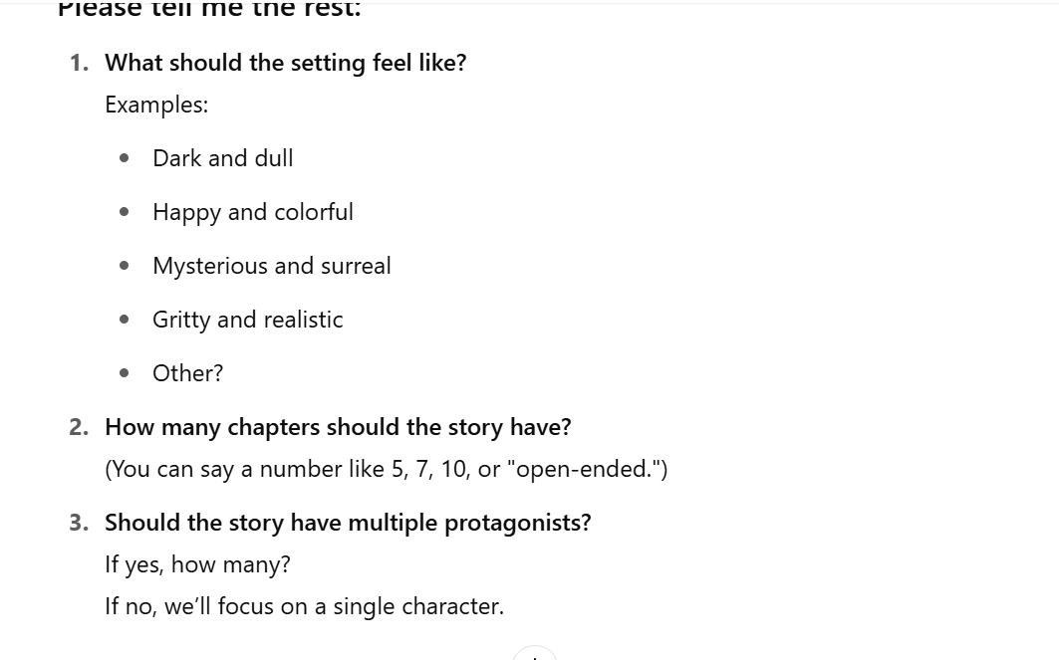

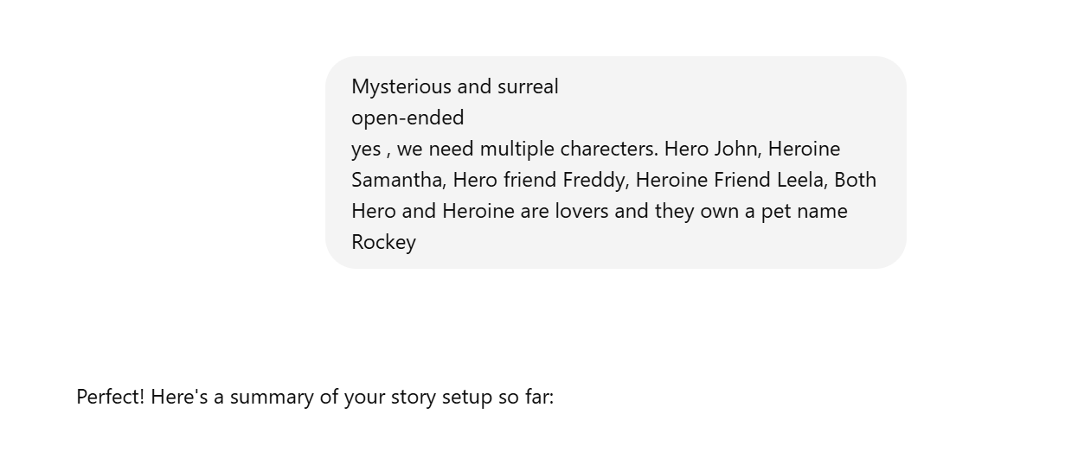

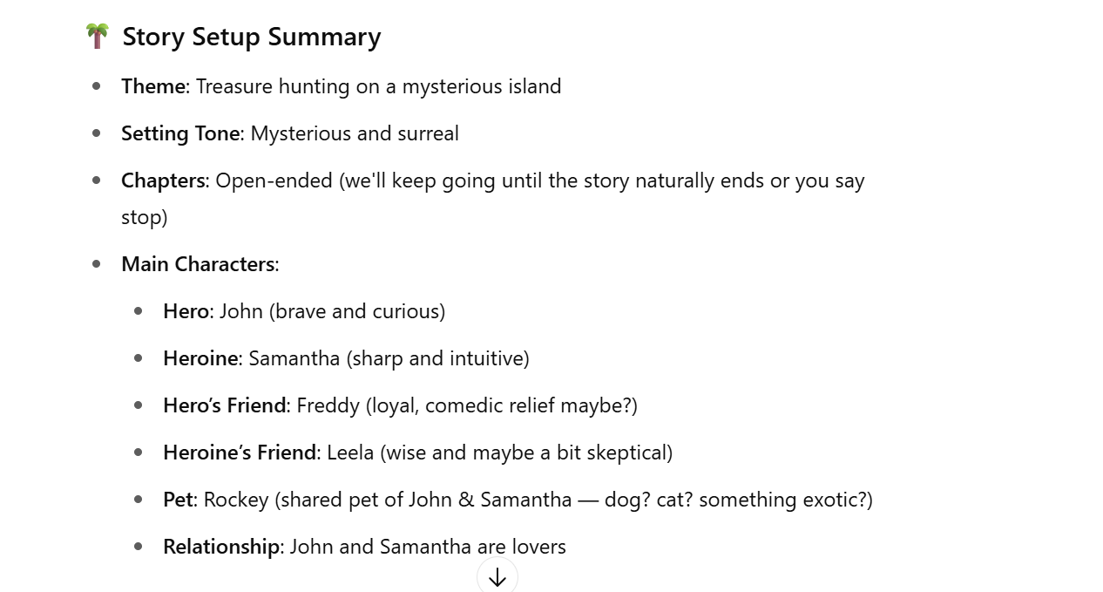

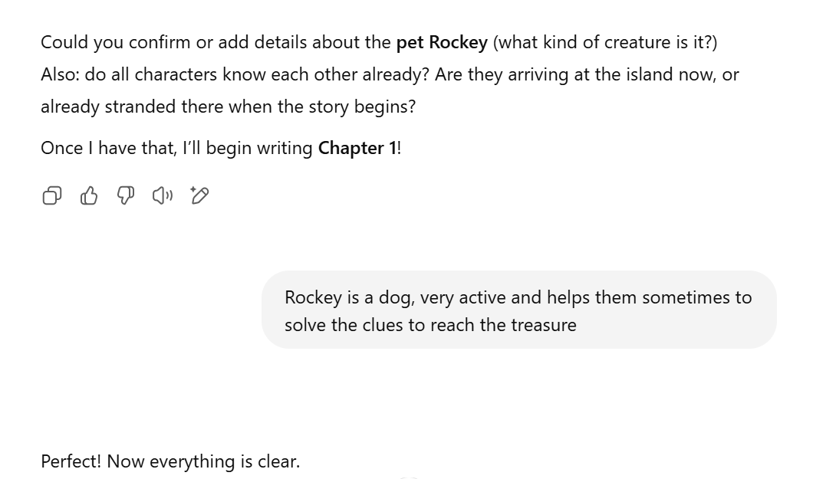

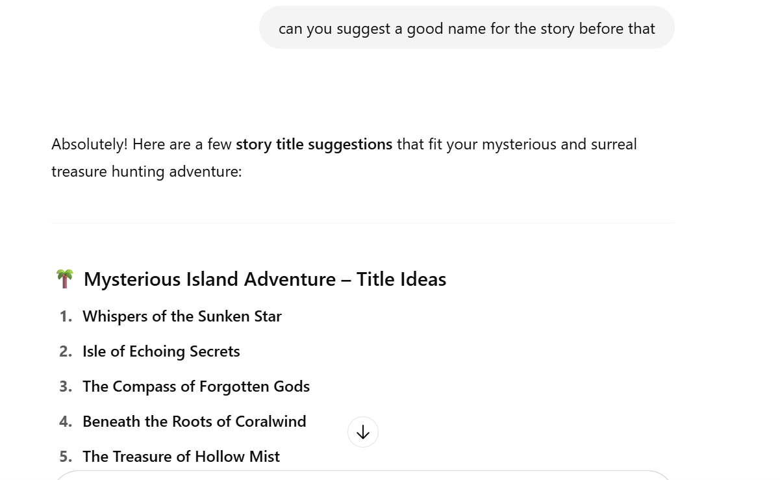

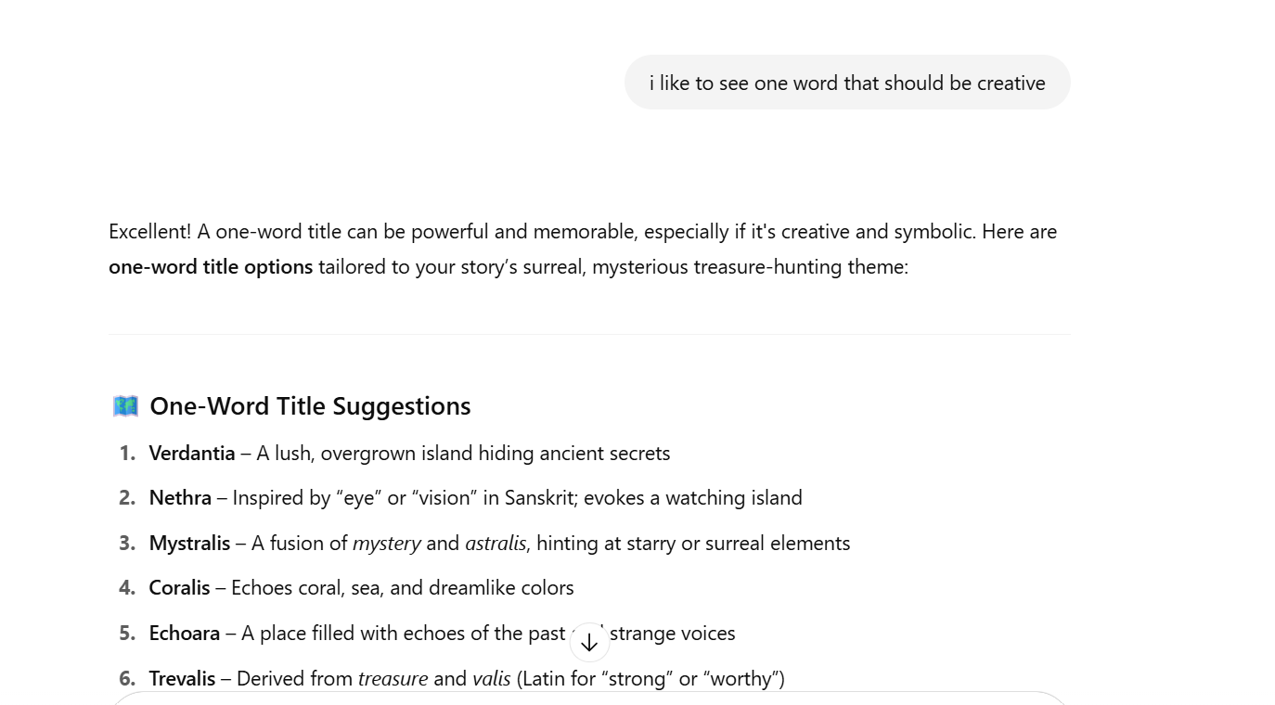

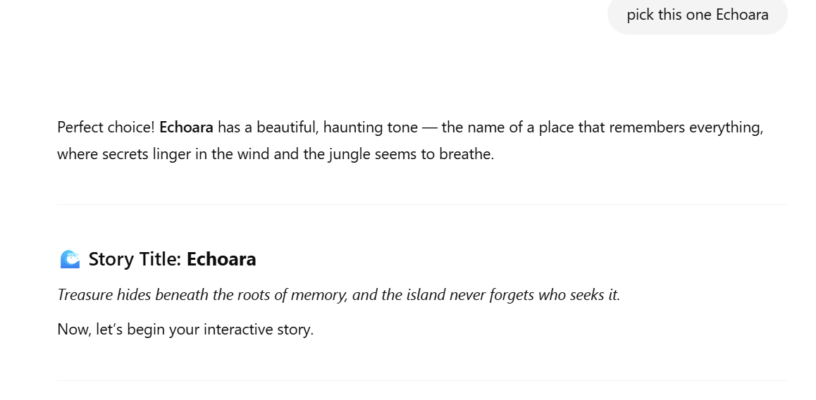

After Chapter 1

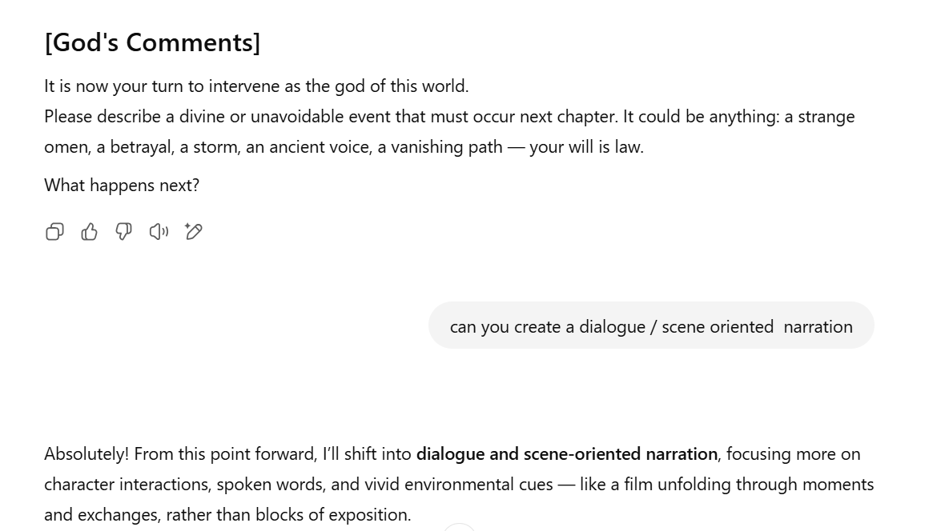

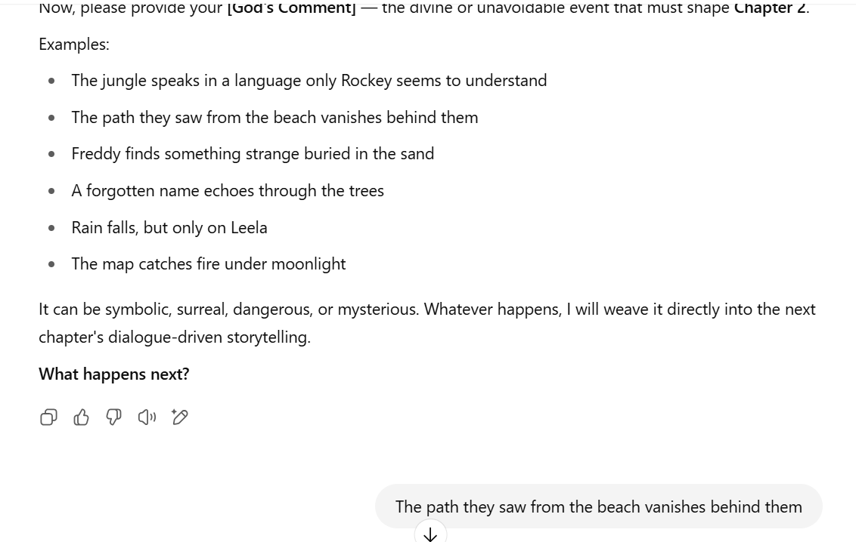

Then the interaction went like below

# ECHOARA

**Story Setup**

* **Theme**: Treasure hunting on a mysterious island
* **Setting Tone**: Mysterious and surreal
* **Chapters**: Open-ended
* **Protagonists**:
  + **John** – Hero, brave and curious
  + **Samantha** – Heroine, sharp and intuitive
  + **Freddy** – John's loyal, fun-loving friend
  + **Leela** – Samantha’s wise, skeptical friend
  + **Rockey** – A very active and intelligent **dog**, helps solve clues during the treasure hunt
* **Relationships**: John and Samantha are lovers; all four humans are friends and part of the same expedition
* **Status**: They are about to arrive at the island

**Story Title: Echoara**

*Treasure hides beneath the roots of memory, and the island never forgets who seeks it.*

Now, let’s begin your interactive story.

**[Chapter 1]**

*Time of Day: Dawn – gentle waves cradle the boat as it nears the island of Echoara*

A gray-pink sky stretched over the restless sea. The first light of dawn spilled gently across the surface, casting a pale shimmer that made the island ahead look like it was sleeping. Mist clung to the dense green hills like breath on a mirror. Nothing about Echoara looked welcoming, and yet all five travelers leaned forward, eyes locked on its mysterious silhouette.

John stood at the bow, his hand resting on the head of Rockey, their eager brown-furred companion. The dog’s ears perked, nose twitching at the salt and secrets in the air. John said nothing, but his heart pounded in rhythm with the sea. He could feel it — something was waiting.

Samantha joined him, brushing her dark hair behind one ear. “This place doesn’t feel real,” she whispered, watching the jungle trees sway gently even though no wind touched their boat.

Leela, ever cautious, was checking her compass. “This island shouldn’t be here,” she muttered for the third time since sunrise. “It’s not on any modern maps. Not even the ancient charts Freddy found mention it by name. And yet…”

“Yet here we are!” Freddy called from the rear of the boat, grinning as he guided them toward a narrow beach between two tall cliffs. His voice was too loud for the stillness, but that was just Freddy — trying to keep the fear from setting in. “Land ho, crew! Get ready for coconuts, curses, and maybe buried gold!”

Samantha gave John a look. “He thinks this is a game.”

John smiled, but it didn’t reach his eyes. “We’ll see who’s still laughing when the map starts making sense.”

They had found the map six months ago, hidden in the false bottom of an old sailor’s trunk at a coastal antique shop. It wasn’t inked — not in any way they understood. Instead, the strange paper seemed to react to firelight and moonlight differently, revealing new lines, runes, and moving landmarks. They had followed its shifting instructions across oceans, and now it had finally pointed them here.

Rockey suddenly barked, tail wagging, eyes locked on the beach. The mist was thinning, and from the boat, they could now see a narrow path winding into the jungle, almost like an invitation.

John glanced at the others. “This is it.”

Freddy secured the anchor while Leela carefully packed the map into her waterproof satchel. Samantha kissed John briefly, then whispered something to Rockey, who gave a soft yip of approval.

They stepped off the boat and onto the sand. The moment their feet touched land, a low hum echoed through the trees — deep, harmonic, almost musical. Rockey whined and looked up.

The jungle had begun to whisper.

**[God's Comments]**

It is now your turn to intervene as the god of this world.  
Please describe a divine or unavoidable event that must occur next chapter. It could be anything: a strange omen, a betrayal, a storm, an ancient voice, a vanishing path — your will is law.

**What happens next?**

**The path they saw from the beach vanishes behind them**

**[Chapter 2]**

*Time of Day: Morning – somewhere inside the outer jungle of Echoara*

**Samantha** bent down and brushed her fingers over the soil. “I swear… this was it. The trail started right here. I saw it. We all saw it.”

**Freddy** turned in a slow circle, frowning. “I mean, it wasn’t a *great* path, more like a creepy welcome mat, but yeah—it was definitely here.”

**Leela** stepped back toward the trees, holding her compass up to her face. The needle spun lazily, ignoring north. “I don’t like this,” she said. “It’s like we’ve been swallowed.”

**John** scanned the jungle wall that now surrounded them — a sudden ring of dense ferns and root-choked trees where open sand had been only moments ago. “No footprints, either,” he muttered.

**Rockey** sniffed the ground with increasing frustration. He circled once, twice, then growled low — not in fear, but in confusion. His tail was rigid.

*Behind them, the beach was gone. Not faded — gone. Replaced by dense vegetation, just as thick and wild as everything ahead. As if the island had blinked and changed its mind.*

A faint sound shimmered through the leaves. A distant chime, like wind passing over glass bottles.

**Samantha** straightened up, her voice tight. “We’ve been here five minutes. And it’s already messing with space.”

**Freddy** rubbed his arms. “So, uh… are we in trouble? Like cursed kind of trouble, or just lost kind of trouble?”

**Leela** snapped her compass shut. “We should have brought chalk. Or string. Or a flame-thrower.”

**John** turned toward the jungle, jaw clenched. “No panic,” he said firmly. “We go forward. The map showed this island. The clues are here. We just have to trust that it wants to be solved.”

**Samantha** gave a short laugh. “An island that wants to be solved? You make it sound like it’s alive.”

Silence.

**Rockey** barked — once, sharp — and then darted toward a cluster of vines that looked like a dead end. He began digging furiously at the base of a root.

**Freddy** blinked. “Uh. Did Rockey just find something?”

**Leela** stepped closer, brushing vines aside with the back of her hand. “Wait. That’s… that’s not a wall of plants. That’s a *door.*”

They all gathered around.

Behind the vines, revealed under layers of moss, was an arched stone — carved with strange glyphs, and beneath it, a rounded tunnel mouth that sloped downward. The inside was unnaturally dark. No light reached in.

**Samantha**: “We didn’t see this before.”

**John**: “Because it wasn’t there before.”

**Leela**: “Or because it was watching us. Deciding.”

Freddy reached for his flashlight, flicked it on, and shone it into the tunnel. The beam caught on stone — then something metal. A symbol shaped like an eye, carved in gold.

**Rockey** wagged his tail once, then sat, as if waiting for someone else to go first.

They stood there for a long second — four friends and a dog, surrounded by a jungle that had stolen their way back. The air around them thickened with silence.

And then John took the first step into the dark.

**[God's Comments]**

The jungle has hidden the path back. They’ve entered something ancient. Echoara has now *chosen* them.

**What divine or unavoidable event happens in Chapter 3?  
Your will shapes their journey.**

**The jungle speaks in a language only Rockey seems to understand**

**[Chapter 3]**

*Time of Day: Late Morning – underground tunnel, sloping deeper into Echoara*

**Freddy’s** flashlight flickered, casting quick-moving shadows across the stone walls. The tunnel was tight at first, then opened into a large, circular chamber. Roots coiled across the ceiling like veins. Somewhere far above, water dripped — a slow, steady rhythm, like a heartbeat.

**Samantha** ran her hand along the etched wall. “These carvings are old. Older than anything I’ve studied. They’re not just decorative — they’re… musical?”

She pressed her ear to the stone. A faint hum vibrated through it. A melody with no tune. No words.

**Leela** crouched near a pedestal in the center of the room — a stone block, weathered and cracked, with a deep bowl carved into its top. Inside the bowl, small black stones shimmered, though no light touched them.

“Anyone else getting serious ‘ritual sacrifice’ vibes here?” she muttered.

**John** didn’t answer. He was watching **Rockey**.

The dog stood completely still, ears twitching, eyes locked on one of the tunnel’s side passages. His head tilted slightly. Then tilted again. He took a few steps toward it — paused — and whined softly.

Then he barked. Not loudly. Not playfully. It was a short, commanding bark, like he was saying something urgent.

**Freddy** raised an eyebrow. “What was that? Why does that sound like he’s giving *orders*?”

**Rockey** barked again. Then he turned and trotted toward the passage. Halfway there, he stopped, looked over his shoulder, and whined.

**John**: “He wants us to follow.”

**Leela**: “No. *You* want to follow. He’s a dog.”

**Samantha**: “He’s *our* dog. And he’s never acted like this before.”

**Freddy**: “He found that hidden tunnel. He might be picking up something we can’t.”

**Leela**, frowning: “Like what? Scent?”

**John**: “No. Sound.”

There it was again — so faint it felt imagined: a layered whisper, not in words but in *rhythm*. The rustle of unseen leaves. A low echo in the stone. The kind of sound that doesn’t touch your ears — just your spine.

**Rockey** let out a growl, almost... impatient.

Then, from the shadows of the tunnel he faced, the roots along the wall *twitched*.

**Freddy**: “Did that root just—?”

**Samantha**: “Yes.”

The air felt thick. Warmer. The chamber’s low hum grew more complex — a sound like leaves brushing against a hollow drum. **Rockey** stepped forward, hackles raised, not in fear, but in purpose.

**Leela**: “This is insane. What if that passage collapses? Or what if it’s… I don’t know, bait?”

**Rockey** barked again — a sharp, almost scolding sound. Then he looked at John.

**John** nodded. “I trust him.”

He turned to the others. “We follow.”

With that, he stepped into the passage, Rockey leading just ahead. The others, hesitant, exchanged glances — and then followed one by one.

*Behind them, the chamber quieted. The whispering faded into the stone. And somewhere deep within the roots above, a voice no human could decipher pulsed like a forgotten lullaby — speaking only to the one creature who could understand: Rockey.*

**[God's Comments]**

The jungle has begun to speak — and Rockey is listening. The others can only follow where he leads.

Now, god of this story, what unavoidable event will shape **Chapter 4**?  
Your command sets the tone for what unfolds next.

**You said:**

A forgotten name echoes through the trees

**ChatGPT said:**

Your divine command shall ripple through the vines and stone:

**🌿 [God’s Comment – Chapter 4]**

**A forgotten name echoes through the trees.**  
No one speaks it, yet each person hears it in their own voice. It doesn’t mean anything to them — not yet — but Rockey freezes, ears back, tail down. The jungle remembers someone… or is calling for someone.

**[Chapter 4]**

*Time of Day: Early Afternoon – deep jungle trail, beyond the tunnel*

The tunnel ended in light.

A moss-covered arch gave way to a high canopy, where golden beams of filtered sun danced across the ferns. The air was warmer now, heavy with the scent of wet bark and crushed fruit. The trees here were taller, older, almost... watchful.

**Freddy** squinted upward. “Feels like we’re inside a cathedral built by trees.”

**Leela**: “Too quiet for my taste.”

**John** adjusted the strap of his pack, his eyes scanning the narrow trail that continued ahead. “No birds. No bugs. No wind.”

**Samantha**, softly: “It’s listening.”

**Rockey** had stopped. His tail was rigid, head low, ears angled backward. A low whine rumbled in his chest.

“Rockey?” John stepped closer. “What is it?”

Then they all heard it.

A voice. Thin as mist. Not spoken, not whispered, but *present.*

It came from the trees — or the sky — or beneath their feet. It was hard to tell. A single word.

***“Anarah…”***

Each of them froze. The sound wasn’t loud. It slid inside their heads like a memory they couldn’t place.

**Leela**, blinking hard: “What the hell was that?”

**Freddy**, after a long pause: “Was that a name?”

**Samantha** looked at John. “Did you hear it in your voice?”

He nodded slowly. “Yeah. Like I was remembering saying it.”

**Leela**: “Same here. Like déjà vu, but… not mine.”

**Rockey** whined again — louder now — then let out a deep, defensive bark. He turned in a slow circle, growling toward the trees, toward nothing visible.

Then, just like that, he sat. Still growling. Ears flat.

**Freddy** stepped toward the trees. “Maybe it’s another traveler. Someone stuck here. Maybe calling for—”

***“Anarah…”***

Again. Clearer. Closer. This time it carried on the breeze — though no leaves moved.

**Samantha**, suddenly pale: “What if it’s not calling for help… but *remembering* someone?”

**Leela** looked over her shoulder, into the trees. “Or calling someone *back.*”

There was movement then — deep in the underbrush. Not an animal. Not wind. Just… a presence. Watching.

Rockey gave a single bark, then ran forward — off the trail, into the brush.

**John**: “Rockey! Wait!”

He charged after him, branches snapping, vines tugging at his clothes.

**Samantha**: “John!”

They all followed — stumbling through tangled roots and thorned plants, until suddenly…

The forest opened into a strange glade. Soft blue flowers covered the ground in an unnatural spiral. At the center stood an **old stone altar**, half-swallowed by vines. Carvings on it were worn smooth — but one was still clear.

A name.

***Anarah.***

And below it… something scratched in fresher strokes.

***“She remembers. So must you.”***

**John** stood there, stunned. “Who is she?”

**Samantha** looked at him — eyes narrowing. “You said that like you almost knew.”

**Freddy**, glancing around: “Okay, weird question, but — does anyone else feel like we’re being… *invited* to remember something?”

**Leela**: “No. Not invited. *Expected.*”

Rockey stood at the altar, staring into the trees. Silent now. But his body trembled, his eyes locked on something the others couldn’t see.

*The jungle was no longer whispering. It was waiting.*

**[God's Comments]**

Anarah’s name has returned to the air. Echoara is remembering someone — or asking them to remember her.

What divine or unavoidable event should occur in **Chapter 5**?  
The fate of the story bends to your will.

**You said:**

They Recollect their old friend Anarah who helped them to escape from a train accident unfortunately she died in that accident. Before she died she took a promise from them that they will offer plenty of water to 100 trees and take the responsibility to save the environment.

**ChatGPT said:**

Your divine command flows like a river through memory and guilt:

**🌿 [God’s Comment – Chapter 5]**

**The group begins to remember Anarah — their lost friend.**  
She once saved them from a deadly train accident, giving her life in the process. Before her final breath, she made them promise something sacred: **to offer plenty of water to 100 trees** and to **take responsibility for protecting the environment.**

Echoara now echoes with her name — not just as a ghost, but as a bond unfulfilled.

Now I will write **Chapter 5** in a character-driven, dialogue-oriented style, drawing the past into the present, binding the island to their forgotten promise.

**[Chapter 5]**

*Time of Day: Mid-Afternoon – Anarah’s Glade, surrounded by spiraling blue flowers*

No one moved.

The glade held them in silence. Sunlight filtered through the canopy like it was underwater. Time didn’t feel right anymore.

**John** stared at the name carved in stone.

“Anarah…” he murmured. “Why does it feel like we left her behind?”

**Samantha** stepped forward slowly, her voice shaking. “Because we did.”

**Freddy**, confused: “Wait—what are you two talking about?”

**Leela’s** eyes widened. “No. No way. I—how could I forget this?”

John nodded slowly, eyes distant. “That train… It was raining. We were late getting on. She was already sitting by the window.”

**Samantha**, tears forming: “She saw the crack in the rail first. Pulled the emergency brake. The train still derailed, but… she got us out of that car.”

**Freddy** clutched his head. “Why the hell didn’t I remember this?”

**Leela**, whispering: “Because we didn’t want to. We buried it. Buried *her*.”

**Rockey** gave a quiet whimper and lay down beside the stone.

The memory settled over them — sharp and full of sorrow.

Anarah. Her name spoken only once at the funeral. Her promise... made in blood and breath, whispered through cracked lips as medics tried to stop the bleeding.

**“Please… promise me. Save the trees. Offer them water. One hundred. No less. Make it right.”**

**Samantha** fell to her knees in the flowers. “We *said* we would. We *meant* it.”

**John**, bitter: “And then we just went on with our lives. Like we never owed her anything.”

**Freddy** sat down hard, elbows on his knees. “We got caught up in other stuff. The map. The journey. The treasure…”

**Leela**, angry: “We made a *vow.* A dying vow. And now we’re standing on her name, wondering why this island won’t let us leave.”

The glade pulsed softly. A gentle breeze moved through the trees in a single wave, like breath from the earth. Leaves shimmered. And somewhere in that breath…

***“You promised.”***

Each of them turned toward the sound — not startled, but solemn.

**Samantha**, eyes fixed on the spiral of flowers: “This isn’t about gold. It never was. The treasure… is the vow.”

**John**, to the others: “If we want to move forward, we have to honor her.”

**Leela** nodded. “We start now.”

**Freddy**, standing: “There’s water in the packs. There’s trees *everywhere.* Let’s give Echoara what it deserves.”

**John** reached into his pack and uncapped a canteen. He walked to the base of the tallest tree in the glade, knelt, and poured the first offering into the roots.

**“One.”**

Samantha joined him. “Two.”

Then Leela. “Three.”

Freddy. “Four.”

**Rockey** barked softly. Then, tail wagging, he began to dig a shallow trench between roots, helping the water flow.

*The jungle stirred. The wind picked up, warm and fragrant. And far, far in the distance — from deep within Echoara — a soft chime rang out. Not a warning… but perhaps approval.*

**[God's Comments]**

The memory of Anarah returns with weight and purpose. The jungle may now begin to trust them again — or test them harder.

What divine or unavoidable event must happen in **Chapter 6**?  
Will Echoara offer guidance? Or set a trial in motion?

**You said:**

Jungle started trusting them again

**ChatGPT said:**

Your divine will breathes new life into Echoara:

**🌿 [God’s Comment – Chapter 6]**

**The jungle begins to trust them again.**  
It senses their sincerity, their remembrance of Anarah, and the first steps of fulfilling their vow. Now, the island shifts subtly — paths once hidden begin to reveal themselves, and the air becomes lighter. But trust from Echoara is never given freely… it must be proven, again and again.

Now, I will write **Chapter 6**, capturing this moment of fragile alliance between the humans and the island — rich in **dialogue and scene-driven storytelling**.

**[Chapter 6]**

*Time of Day: Late Afternoon – Still in Anarah’s Glade, now awakened*

The last of the water spilled into the roots of the tenth tree. Each trunk they’d chosen stood taller, leaves seeming to rustle with approval. Even the soil looked darker now, richer — as if it had drunk deeply after a long thirst.

**Samantha** sat back and exhaled. “That’s ten.”

**Freddy** wiped sweat from his brow. “Ninety more to go.”

**Leela**, softly: “But it feels… lighter here. Doesn’t it?”

She was right. The air had changed. The clinging heaviness had lifted, replaced by something fresher, almost *hopeful*. Sunlight slipped through the trees in broader rays now. The shadows no longer pressed in. Instead, they stretched softly, like the island was watching them… and pleased.

**John** stood, brushing dirt from his hands. “Look.”

He pointed beyond the glade.

What had once been a dense wall of green was now parted — a narrow path winding deeper into the forest, lined with glowing white blossoms that hadn't been there moments ago.

**Leela**, cautious but amazed: “That was solid jungle five minutes ago.”

**Freddy**: “Guess this is the jungle’s version of a thumbs-up?”

**Rockey** barked twice, tail wagging, and bounded down the path without hesitation.

**Samantha**, smiling faintly: “He knew this would happen. He *felt* the shift.”

**John**: “He’s been the jungle’s voice since we arrived. Maybe now… we’re finally being heard too.”

They followed.

The path led them through a new part of the island. Trees arched overhead like a cathedral roof, and the flowers lining the trail gave off a soft bioluminescent glow. For the first time since arriving, it felt like they weren’t just moving — they were *being guided*.

The farther they went, the stranger the jungle became.

They passed trees with bark that shimmered like metal. Roots shaped like fingers. Vines humming low notes when touched by wind. And in the distance — faint, melodic whispers. Not words. Not warnings.

Welcome.

**Leela**, glancing at the strange foliage: “The deeper we go, the older this place feels.”

**Freddy**: “Yeah. Like... time doesn’t work the same here. Or *never* did.”

They rounded a bend.

And there it was.

A towering structure carved from black stone — part temple, part monument — hidden beneath a massive banyan tree whose roots wrapped protectively around it. Strange symbols pulsed faintly across its surface.

**Samantha**, breath catching: “Is that... the center of the map?”

**John**, nodding slowly: “It has to be. But we’re not ready yet.”

He turned to the others. “We’ve only watered ten trees. We haven’t earned it.”

**Leela**: “Then let’s not rush. Let’s finish what we promised.”

**Rockey** barked once — then trotted off into the woods again, stopping briefly to look back.

Waiting.

*And as they followed, for the first time, the jungle sang for them — a soft, choral hum rising from the trees and stones. Echoara was watching. And trusting. For now.*

**[God's Comments]**

Echoara has opened a path — but trust must still be nurtured.

What divine or unavoidable event must shape **Chapter 7**?  
Do the travelers find a clue? Does someone begin to change? Or does the island reveal a danger, testing their resolve once more?

**You said:**

Now suddenly rain falls but the rain falls on only leela. Leela is not getting wet either.

**ChatGPT said:**

Your divine command descends like a mystery in the form of rain:

**🌿 [God’s Comment – Chapter 7]**

**Rain begins to fall — but only on Leela.**  
The others feel nothing. The canopy remains dry. Yet above Leela, drops appear from nowhere, falling straight onto her… and passing through her. She isn’t getting wet. The water evaporates mid-air — or phases through her. The jungle watches.

Now, I will write **Chapter 7**, capturing this surreal, dialogue-rich moment — as the island once again bends the rules of nature to whisper something unknown.

**[Chapter 7]**

*Time of Day: Evening – trail between Anarah’s Glade and the black stone monument*

The trail curved around a large cluster of twisted trees, their trunks braided together like rope. The glowing blossoms still pulsed faintly at the edges of the path, and **Rockey** led the group forward with purpose — nose low, tail wagging steadily.

**Freddy**, whistling: “I’m not saying this island is *friendly* now, but it definitely stopped trying to kill us.”

**Samantha** smirked. “Give it time.”

**John**, thoughtful: “No. She’s right. Something’s changed.”

Suddenly — a soft pattering sound, just above them.

**Drip. Drip. Drip.**

Everyone stopped.

**Samantha**: “Do you guys hear that?”

**Leela** frowned, lifting her face. “Rain?”

**Freddy**, looking around: “There’s not a single cloud in the sky.”

Then, the sound got louder — **only above Leela.**

She looked up. **Tiny droplets** shimmered in the air above her, falling gently… but they didn’t splash. They didn’t even touch her skin.

They *passed through her* like mist through moonlight.

**Leela** held out her hand. “What…?”

Her palm remained dry. The rain hit, and simply vanished on contact.

**Samantha** stepped closer. “Is it only falling on you?”

**John** reached out toward the space above her head — his hand passed through dry air. “There’s nothing here. Not for us.”

**Rockey** gave a confused bark and backed away slightly, head tilted. He circled Leela once, sniffed the ground — then whined.

**Leela**, trying to stay calm: “Am I… marked? Is that what this is?”

The droplets sparkled faintly in the air, like glass beads in slow motion. The rain intensified for a moment, then slowed… but never *touched* her. And she still felt nothing. No wetness. No cold. Just a gentle vibration in her bones — like the jungle had put a finger on her soul.

**Freddy**, quietly: “I don’t think it’s a threat.”

**Samantha**: “It’s a message.”

**John** looked into the trees. “Or a memory.”

Then, for just a heartbeat — the rain falling over Leela **hummed**.

A soft, rising tone. Like a voice warming its chords. It wasn’t in a language — not quite — but it *wanted* to be.

**Leela’s** lips parted slightly, as if something inside her was stirring. Her eyes were wide. Still. Listening.

**Samantha**, carefully: “What do you hear?”

Leela didn’t answer. Her gaze had shifted, unfocused — like she was somewhere else.

Then, softly:

**Leela**: “I see her.”

Everyone stiffened.

**John**: “Who?”

**Leela**, almost whispering: “Anarah. In a red shawl. Standing in the rain. She’s not speaking. But she’s watching me.”

**Samantha**, voice low: “Why only you?”

The rain stopped.

All at once. A heartbeat of silence.

Leela blinked and swayed on her feet. **Rockey** rushed forward and licked her hand, grounding her.

**Freddy**: “Leela, are you okay?”

She nodded slowly. “She wasn’t angry.”

**John**: “What was she, then?”

Leela looked up at the dark canopy, her voice steadier now. “Waiting. She’s waiting for me… to remember something I forgot.”

She looked at the others, suddenly serious. “We’re not just here because of the treasure. We’re here because something unfinished from that day — the day of the crash — *never left us.* And I think the jungle knows.”

The forest held its breath.

Then — a soft rustling up ahead.

**Rockey** turned and barked sharply, tail up. The glowing path had grown brighter. A cluster of young saplings, all unmarked, lined the trail just ahead — thirsty.

Leela stepped forward.

She opened her canteen.

*“Eleven.”*

**[God's Comments]**

The jungle has marked Leela — or remembered her. The rain brought more than vision. Something old is awakening.

What divine or unavoidable event must shape **Chapter 8**?  
The fate of Echoara continues to bend under your will.

**You said:**

Leela in her past life, she supported to build a big forest and she was an architect in her past life. so jungle feels she is the best person to protect the jungle

**ChatGPT said:**

Your divine truth awakens old roots buried deep in the soil of time:

**🌿 [God’s Comment – Chapter 8]**

**Leela, in her past life, was an architect who helped build a great forest sanctuary.**  
She designed living structures in harmony with nature — temples wrapped in vines, walkways suspended between trees, irrigation systems that gave life. Echoara now remembers her soul. It marks her not just with trust, but with expectation. The jungle sees her as its chosen protector.

Now, I will write **Chapter 8**, unfolding the return of Leela’s hidden identity — in a dialogue-rich, scene-driven moment where memory and myth begin to blur.

**[Chapter 8]**

*Time of Day: Evening – along the glowing trail, saplings now surrounding them*

They watered twenty more trees.

Each time Leela approached one, the leaves seemed to reach gently toward her. The vines parted more easily for her than for the others. Even **Rockey** began to stay closer to her, his ears twitching as if waiting for her next move.

**Freddy**, scratching his head: “Okay, not to freak anyone out, but the plants are... kinda flirting with Leela?”

**Samantha**, half-smiling: “They’re not flirting. They’re recognizing.”

**Leela**, quietly: “I don’t know why. I’m just—”

She stopped.

The path curved again, opening into a small clearing, where moonlight filtered through the canopy like silver silk. At the center was an ancient **stone seat**, overgrown but clearly sculpted by human hands — or something like them.

Leela froze.

Her breath caught.

**John**: “What is it?”

She didn’t answer.

Instead, she walked to the stone and knelt before it. Her fingers brushed its edge. The moss peeled away like fabric — and beneath it, lines carved deep into the stone. **Architectural drawings.**

**Leela** traced them slowly. Arches. Root-bridges. Water channels. Spiral wells lined with tree rings.

Then she spoke — a voice not entirely her own.

**Leela**: “This is my design.”

The others exchanged glances.

**Samantha**: “You mean… it looks like your style?”

**Leela**, eyes wide: “No. I mean I *made* this. Long ago. Before I was… this.”

A wind blew through the clearing.

The trees bowed slightly.

Rockey let out a long, low howl.

The ground beneath the seat shimmered — not visibly, but **felt**, like heat off stone.

A vision bloomed in Leela’s mind:

*Massive trees rising around stone walkways. Water flowing down spiraled channels into root-fed fountains. Children planting seeds with solemn joy. She had stood there — barefoot, covered in clay and vines, arms outstretched, guiding the builders with voice and hand. Her voice had commanded growth. Her designs shaped life.*

She gasped and stepped back.

**Leela**: “I was… someone else. I lived here. I helped build this island. Not like a city. Like a *guardian’s temple.*”

**John**, stunned: “You helped create Echoara?”

**Freddy**, awestruck: “Holy hell… the jungle wasn’t just trusting you. It *knows* you.”

**Samantha**, stepping forward: “That rain — it wasn’t just a sign. It was a *recognition.* A welcome home.”

Leela looked at her hands.

**Leela**: “Then maybe I’m not here to find treasure. I’m here to finish what I started.”

**Rockey** barked — short and urgent — and ran ahead. The trail brightened.

Up ahead, nestled in the vines, they could see something glowing: the edge of another carved platform — larger, tiered, partially buried in roots.

A temple half-asleep.

And as they moved toward it, the air shimmered again — and a faint phrase rose from the leaves:

***“The one who plants with purpose… must now return to tend the roots.”***

Leela paused.

Then nodded.

**Leela**: “I’m ready.”

**[God's Comments]**

Leela’s past returns like roots pushing up through earth. Echoara is no longer just a place — it is a memory, a responsibility, and a call.

What divine or unavoidable event must shape **Chapter 9**?  
Will a trial begin? Will another character awaken? Or does the jungle reveal the next sacred step?

**You said:**

yes, trail begin

**ChatGPT said:**

Your divine will has been received — and the jungle answers:

**🌿 [God’s Comment – Chapter 9]**

**A trial begins.**  
Echoara opens the first of its hidden trials — a test not of strength, but of spirit, memory, and intent. The group must face illusions, truths, and perhaps even fragments of their past selves. Only through understanding and unity can they move forward. The forest will not be kind… but it will be honest.

Now, I will write **Chapter 9**, where the jungle sets its first trial in motion — with intense, immersive dialogue and shifting reality.

**[Chapter 9]**

*Time of Day: Night – just outside the vine-wrapped temple*

The moon had risen fully now — a pale coin hung above the trees. The temple ahead gleamed faintly, its stone steps partially swallowed by vines and roots, as if the jungle couldn’t decide whether to protect it or keep it hidden.

**Rockey** paced at the temple entrance, nose twitching, tail low. He didn’t bark. He watched.

**Leela** stepped forward first. The carved arch above the entrance pulsed once — not light, but something deeper, like breath through bone.

**Samantha**: “It’s waiting.”

**John**, hand resting on the hilt of his jungle knife: “For what?”

The air answered with a low hum — harmonic, old, bone-deep. The trees around them leaned slightly inward.

Then, the entrance opened.

Not physically. But **reality itself bent** for a moment — the space between the arch shimmered like heat, then resolved into a tunnel of light and shifting shadows. The walls were not made of stone. They were made of *memories.*

**Freddy**, taking a step back: “Guys… I don’t think that’s just a doorway.”

**Leela**, steady now: “It’s the first trial. The island is ready to test us.”

**Samantha**, tightening her pack: “What kind of test?”

**Leela**, looking into the light: “One we can’t fake. Echoara sees who we are.”

**John**: “Then we go together.”

They stepped through.

The air shifted instantly — cold, heavy, and *liquid*. The tunnel flexed, and suddenly they were not underground.

*They stood on a* ***train platform****. Empty. Silent. Wet with recent rain.*

The lights flickered above.

A red shawl lay on the ground.

**Freddy** blinked, breath catching. “Is this… the station?”

**Samantha**, whispering: “The day of the accident.”

**Leela** stepped forward, toward the memory.

Then everything twisted again — and the **train surged into the platform**, impossibly fast. It screeched and sparked, derailing right before them — **but no one screamed**. No people. Just shadows. Just *them* — watching themselves.

A voice echoed through the chaos:

***“To move forward, you must face what you buried.”***

Each of them suddenly stood *alone*. The others were gone.

**John** was back in his apartment — the day he burned Anarah’s journal, unable to face it.

**Samantha** was holding a tree sapling… then walking away, leaving it unplanted.

**Freddy** stood over a compost bin, emptying it into a trash can, muttering, “It’s just one mistake.”

**Leela** stood in the wreckage again — but this time, **she was the one holding Anarah’s hand**. Watching the life fade. And hearing the final words again, not as memory… but as a *command*:

***“You have to protect them. You built this. Don’t let it rot.”***

Tears welled in her eyes.

**Leela**, whispering: “I won’t. I remember now.”

She placed her hand on the wall beside her. “I’m not running anymore.”

Light poured from her palm.

The shadows shattered.

Each of them awoke — standing back in the temple’s entrance hall. Together. Breathing hard.

**John**: “Did you all just…?”

**Samantha**: “Yeah.”

**Freddy**, eyes wide: “We were tested. Not on strength. On honesty.”

**Leela**, breathing steady: “It wanted to see if we truly remembered. And if we meant our promise.”

**Rockey** barked once, proud, then sat beside a new stone door — one that hadn’t been there before.

It creaked open slowly.

And beyond it, a **living map** — glowing roots stretched across a massive chamber, forming rivers, forests, and mountains in green light. At the very center pulsed a red heartbeat: the location of the **true treasure**.

*But even as the path revealed itself, a wind blew through the temple. A second trial waited. And it would not be so kind.*

**[God's Comments]**

The first trial has passed. They faced their truths and did not break. Echoara reveals the treasure’s location — but demands more.

What divine or unavoidable event must shape **Chapter 10**?  
Will another trial begin? Will someone be tempted or lost? Or does the island show a new face entirely?

**You said:**

yes another trial begin

**ChatGPT said:**

Your divine decree echoes through root and stone:

**🌿 [God’s Comment – Chapter 10]**

**Another trial begins.**  
This one is different — not a test of memory, but of **temptation**. The island conjures false treasures, illusions of desires, and alternate futures. Each traveler will face a personal vision: a life of ease, of escape, of selfish dreams fulfilled — but at the cost of the vow. Only those who refuse the illusion can proceed.

Now, I will write **Chapter 10**, unfolding the second trial in a rich, dialogue-driven scene where Echoara tempts each soul — and reveals who they really are beneath the surface.

**[Chapter 10]**

*Time of Day: Deep Night – within the Temple of Roots, after the first trial*

They stood before the living map — veins of green and gold pulsing through the chamber floor like the nervous system of the island. At its center, a single glowing pulse beat like a drum: red, slow, and distant.

**Samantha**: “That’s the heart of the island.”

**Freddy**, grinning: “So what, we just head that way and grab the loot?”

**Leela**, serious: “No. It’s not that simple. It never was.”

**John** narrowed his eyes. “It’s *never* that easy when we’re this close.”

**Rockey** let out a low whine and stepped back.

Then the map… flickered.

The glowing roots faded, and the floor beneath them changed — no movement, no warning. Just *new reality*.

*Suddenly, each of them stood alone again — but this time, not in the past.*

They were somewhere else entirely.

**John’s Illusion**

He stood on a white sand beach. The treasure was open before him — **gold, weapons, scrolls glowing with power**. He wore a crown. Samantha was beside him, smiling, radiant, untouched by danger.

**Samantha’s Voice**: “We can stay here. We have everything. We *earned* this.”

**John** hesitated. “But… the others—”

**Samantha**: “Forget the others. The jungle is healed. It doesn't need you anymore.”

He stepped closer to the treasure. The scrolls pulsed, promising knowledge. The blades whispered power.

But then… a whisper in the wind: *"You promised."*

John looked at the trees. They were wilting.

He clenched his fists — and turned away from the treasure.

**John**: “This isn't real. And I’m not done.”

The illusion shattered.

**Samantha’s Illusion**

She stood in a botanical laboratory, lush with thriving plants — her designs, her name etched in gold on the glass walls. Outside, cities greened. A screen read: *Samantha Reeds — Nobel Laureate for Climate Restoration.*

**Voice on Intercom**: “The jungle doesn’t need saving anymore. You’ve done enough.”

She felt warmth. Legacy.

Then… a dry breeze blew through the glass.

One tree — at the center — began to rot.

A whisper: *"You offered to water a hundred."*

Samantha closed her eyes.

**Samantha**: “Not without the others. Not without her.”

She crushed the touchscreen. The vision crumbled.

**Freddy’s Illusion**

He stood in a massive stadium, lights blaring, crowd cheering. He was rich. Famous. Hosting a wild adventure show called *“Treasure or Terror.”*

**Audience Chanting**: “Freddy! Freddy! Freddy!”

A golden briefcase sat beside him.

Then the lights flickered.

He turned — and saw **Rockey**, sitting alone on a dry patch of soil, eyes dull.

Freddy knelt. “Rockey?”

The dog didn't move.

The crowd went silent.

**Freddy**, softly: “No deal.”

The stadium vanished.

**Leela’s Illusion**

She stood in a garden of glass and living architecture — **a forest city**, thriving, beautiful. Her structures stood for generations. No conflict. No decay.

A voice whispered: “Stay. Rule. Be remembered.”

She stepped forward — but then the earth beneath her feet cracked.

The roots were hollow.

Dead.

The forest was an illusion.

She saw Anarah standing among the withered trees.

**Leela**: “I’ll plant the real ones. No shortcuts.”

She touched the ground. The fake forest collapsed.

*The visions fell away. One by one, they returned to the temple’s heart — changed, tired, but whole.*

Rockey ran to each of them, tail high, eyes bright.

They’d all said no.

And the map returned — now glowing **brighter**, more defined.

But a new symbol pulsed beside the treasure: a **dark spiral**. A final guardian. The third trial.

**Leela**, breathing hard: “We’re close now.”

**John**: “Closer than we’ve ever been.”

**Samantha**: “One more test.”

**Freddy**: “Let’s hope it’s not ‘fight a tree monster.’”

Rockey barked once — then looked toward the jungle beyond the temple.

And the trees shifted again.

**[God's Comments]**

The illusions are broken. Each of them chose truth over comfort. But now the final trial awaits — a shadow deeper than memory or desire.

What divine or unavoidable event must shape **Chapter 11**?  
Will the third trial begin? Will the jungle turn hostile once more? Or does something ancient finally awaken?

**You said:**

lets start the final trial

**ChatGPT said:**

Your divine will has shaken the roots of Echoara:

**🌿 [God’s Comment – Chapter 11]**

**The final trial begins.**  
This one is unlike the others — not of memory, not of temptation, but of **confrontation**. An ancient force, buried deep beneath Echoara, awakens to judge whether they are truly worthy of the treasure and the vow. It is the **Guardian of the Vow**, shaped from everything they forgot, betrayed, and failed to protect. It is not evil… but it will not let them pass easily.

Now, I will write **Chapter 11**, where the final trial begins — dialogue-rich and surreal, a face-to-face with the very soul of the island.

**[Chapter 11]**

*Time of Day: Midnight – leaving the temple, following the path toward the treasure’s heart*

The forest had gone silent again.

Not in hostility — in **ritual**.

Each step forward felt like a drumbeat. Trees parted of their own will, allowing the group to pass deeper than they had ever gone. No map led them here now. The path glowed underfoot, roots guiding them like veins carrying blood.

**Freddy**, walking behind Rockey: “Why do I feel like we’re walking into something older than the island itself?”

**Leela**, eyes fixed ahead: “Because we are.”

They reached the edge of a clearing.

Moonlight spilled down through an opening in the canopy — a perfect circle of silver light. In the center was a stone platform… and above it, **nothing**.

Nothing but still air.

**Samantha**: “Is this it? Where the treasure is?”

**John**, cautious: “No. This is where the final question gets asked.”

Then the wind changed.

And the **Guardian arrived**.

It did not walk. It did not rise.  
It simply *was*.

First a shadow. Then a shape. Then a presence too vast to be real — **an enormous figure made of bark, bone, wind, and memory**, its face hidden beneath vines, its limbs more like tangled trees than arms. Its voice came through **roots, rain, and time itself.**

***“You return with the vow half-kept.”***

The group stood frozen.

**Rockey** growled low, but didn’t bark. He lay down — ears flat, eyes locked on the Guardian.

***“You seek the treasure. But the treasure is not gold. It is not power. It is not escape.”***  
***“The treasure… is a burden. Will you carry it?”***

Silence.

Then:

**Leela**, stepping forward: “Yes.”

The Guardian did not move.

***“Then face yourselves. As you truly are.”***

With that, the platform cracked — and **mirror-light exploded** outward.

**The Trial Begins**

Each of them stood opposite a reflection — a **twisted version of themselves**.

Not evil. Not corrupted. Just... *wounded.*

* **John**, cold and calculated, trading forests for fame, leaving behind promises with a smile.
* **Samantha**, locked in sterile laboratories, worshipping data while trees died just out of frame.
* **Freddy**, rich but alone, his jokes echoes in empty halls.
* **Leela**, sitting on a throne of roots that no longer grow, surrounded by hollow forests she built but never loved.

They spoke — not loudly, but honestly.

**John’s Reflection**: “You’re afraid of failing again. That’s why you keep chasing instead of building.”

**Samantha’s Reflection**: “You hide behind science. But even nature doesn’t always give you answers.”

**Freddy’s Reflection**: “You think being funny makes you harmless. But you *knew* what was at stake.”

**Leela’s Reflection**: “You built so much. But never stopped to *tend it*. That’s why it died.”

**Leela**, teeth clenched: “We’re not those people anymore.”

**Guardian**:

***“Then show me. Heal what you broke.”***

The reflections moved — slowly, like shadows underwater.

Each real self stepped forward.

And one by one, they **embraced their failures**.

Not with denial.

But with forgiveness.

And the mirror-light **shattered**.

The Guardian stood still.

Then knelt.

And opened its chest — bark splitting like a gate.

Inside was no heart. No gem. No idol.

Only a **seed** — glowing, pulsing, wrapped in golden roots.

***“Plant it.”***  
***“Water it. Tend it. That is your treasure.”***

**Leela** took the seed. Her hands didn’t shake.

She turned.

Walked to the center of the circle.

Kneeling, she placed the seed into the ground.

**Samantha** handed her the last of their water.

**John** whispered: “One hundred.”

And **Leela poured**.

The roots accepted it.

The ground pulsed once.

And from the soil… a shoot rose.

Golden. Alive.

Watching.

Rockey barked once — the loudest he’d barked since arriving.

**[God's Comments]**

The final trial has been faced. The Guardian has yielded. The treasure is planted — not claimed.

What divine or unavoidable event must shape **Chapter 12**?  
Do they now leave Echoara? Does the island change forever? Or does something unexpected bloom from the seed?

**You said:**

yes they now leave Echoara and going towards their hometown. They will explain the importance of the seed to government and get the approval to build a forest.

**ChatGPT said:**

Your divine will now takes root not only in Echoara, but in the world beyond:

**🌿 [God’s Comment – Chapter 12]**

**They leave Echoara** — the trials complete, the vow renewed, and the seed planted. Now they return to the world they came from, carrying not treasure, but purpose. They will face doubt, bureaucracy, and disbelief — but they will tell the truth: that a single seed carries the power to change everything. And they will seek permission to build a forest… one that breathes the memory of Echoara into the world again.

Now, I will write **Chapter 12** — a scene of return, reflection, and new beginnings.

**[Chapter 12]**

*Time of Day: Dawn – two weeks later, back in their hometown*

It was raining again — real rain this time. The kind that hit pavement, soaked shoulders, and made the earth smell alive.

The four of them stood just outside the **Department of Environmental Development**, soaked and buzzing with nervous energy. Each wore the same expression: determined, but exhausted.

**Freddy**, tugging at his damp collar: “I still think we should’ve brought Rockey in with us.”

**Samantha**, adjusting her bag: “He’s safer in the van. And I’m not sure they’re ready for a jungle-dog prophet.”

**John**: “No one’s ready for what we’re about to say.”

**Leela**, holding a carefully sealed case — within it, a single **golden leaf**, still alive despite time and travel: “Then let’s say it loud enough they can’t ignore us.”

Inside, the room smelled like government: recycled air, ink, and slow decisions.

The **Director**, a thin woman with tired eyes, stared at the glowing leaf on her desk.

**Director**: “You’re saying… this came from an uncharted island that disappeared after you planted a mystical seed?”

**Samantha**: “Not mystical. **Biological**. Engineered — or maybe evolved — to carry environmental memory. We believe it can adapt landscapes within weeks.”

**Freddy**, adding: “Also, the jungle kind of… tested us first. So it doesn’t hand itself out to just anyone.”

**Director**, blinking: “You understand how insane this sounds.”

**Leela** leaned forward.

**Leela**: “What sounds insane is that we’ve been pouring billions into carbon capture and watching forests die. This seed — this forest — is alive in a way the world forgot. We’re not asking you to believe a myth. We’re offering you a future.”

There was a long silence.

Then the Director picked up the leaf. It shimmered faintly in her hand — *warm*.

She looked at them.

**Director**: “You’ll need land. Approval. Oversight. Are you prepared for that?”

**John**: “We’re prepared to plant every tree ourselves if we have to.”

**Leela**: “We made a promise. And we’re not breaking it again.”

Three months later, they stood on a hillside just outside the city — once barren, now fenced off, marked **ECHOARA RESTORATION ZONE**.

The ground had been tilled. Irrigation set. A ceremonial circle of ten trees already stood — the first of one hundred.

In the center, Leela knelt, planting the **second seed**, grown from the original.

**Samantha** watered it.

**John** shielded it from the wind.

**Freddy** snapped a photo — then joined them in silence.

And **Rockey**, ever watchful, barked once.

Then sat beside the sapling — like he had done on the island.

The forest was coming back.

Not Echoara exactly.

But something born from it.

Something promised.

**[God's Comments]**

Echoara is no longer just an island. It is a movement — a memory with roots. The vow is no longer buried.

Would you like the story to continue from here — building the new forest, facing new threats, or awakening something deeper?

Or has the first story of **Echoara** reached its end?

**You said:**

yes the first story of Echoara reached its end

**ChatGPT said:**

Then so it shall be.

**🌿 ECHOARA — The End of the First Story 🌿**

The trials are passed.  
The vow is renewed.  
The seed is planted.

What began as a treasure hunt became a reckoning with memory, loss, and the responsibility to heal.  
Not with gold. Not with glory. But with green.

**Echoara** was never meant to be conquered — only remembered. And now, through Leela, John, Samantha, Freddy, and Rockey… it will be.

Not as myth.

But as forest.

**Epilogue — A Whisper on the Wind**

Sometimes, when the wind rushes through the trees outside their new forest, it speaks in a language only Rockey seems to understand.

And once in a while, if Leela is very still…  
She hears **Anarah** whisper:

*“Well done.”*